Ideation Phase
Define the Problem Statements

Date | 29 July 2026
Team ID
Project Name | Plugging into the Future: An Exploration of Electricity Consumption Patterns
Maximum Marks | 2 Marks

Customer Problem Statement Template:
"Plugging into the Future: An Exploration of Electricity Consumption Patterns" focuses on understanding the challenges faced by policymakers, energy providers, and consumers in analyzing electricity usage effectively. The project transforms complex electricity consumption data into clear, interactive visualizations that reveal trends, regional differences, and the effects of significant events such as the COVID-19 pandemic. By providing meaningful insights, it supports informed decision-making, promotes efficient energy management, and helps stakeholders develop sustainable strategies to meet future electricity demands.
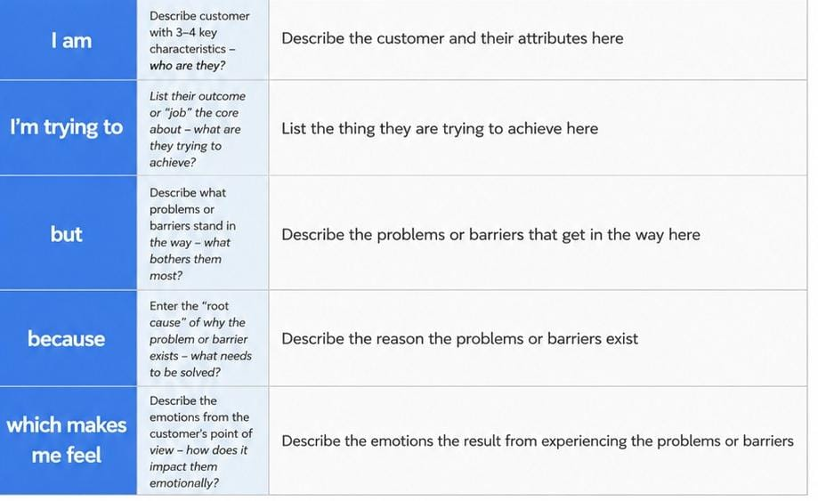
Example: 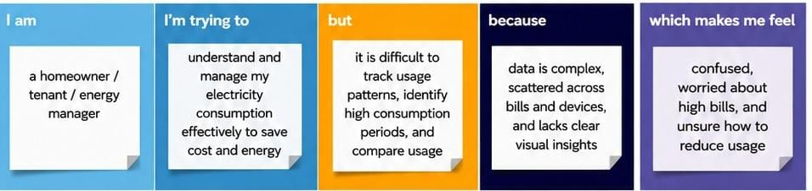

Problem Statement (PS) | I am (Customer) | I’m trying to | But | Because | Which makes me feel
PS-1 | A government energy planner. | Monitor electricity consumption trends across different states and time periods. | I find it difficult to identify consumption patterns and sudden changes using raw data. | The electricity data is large, complex, and spread across multiple regions and months. | Concerned about making effective energy planning and policy decisions.
PS-2 | A power distribution company manager. | Predict electricity demand and manage power supply efficiently. | I cannot easily identify seasonal demand variations and unexpected changes in consumptions. | There is no clear visual analysis to compare historical electricity usage patterns. | Uncertain about resource allocation and maintaining a stable power supply.

